Project Title: Deploy Angular Application in Docker Container
Note: This is a solution document on how the demonstration is performed on Docker 18.+ version.
Install Angular application on Ubuntu by running the commands mentioned below:
sudo apt-get update
curl -sL https://deb.nodesource.com/setup_10.x | sudo -E bash -
apt-get install -y nodejs
npm install -g @angular/cli
ng new myAng-app
cd myAng-app
Run the application in the browser.
ng serve --open
A default browser should open automatically displaying you the Angular application. If you do not see the output, open any browser and add the url in the search bar of the browser:
https://localhost:4200
Your browser should load the output mentioned in the screenshot:
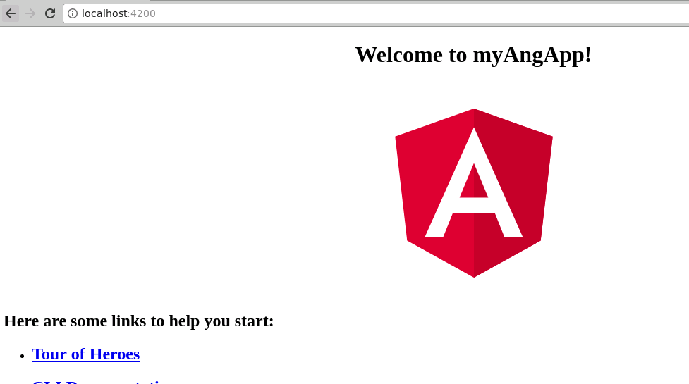

Navigate inside the project, and create a Dockerfile.
touch Dockerfile
Now add the following content to it.
# base image
FROM node:9.6.1

# set working directory
RUN mkdir /usr/src/app
WORKDIR /usr/src/app

# add `/usr/src/app/node_modules/.bin` to $PATH
ENV PATH /usr/src/app/node_modules/.bin:$PATH

# install and cache app dependencies
COPY package.json /usr/src/app/package.json
RUN npm install
RUN npm install -g @angular/cli@1.7.1

# add app
COPY . /usr/src/app

# start app
CMD ng serve --host 0.0.0.0
Create another “dockerignore” file.
touch .dockerignore
Write the following content in it:
node_modules
.git
Build and tag the docker image.
docker build -t myangularapp .
Then reload the container by executing the command mentioned below:
docker run -it -p 4200:4200 myangularapp
Open the browser, and you should be able to run the application in the browser by navigating to the URL mentioned below.
https://localhost:4200
Exit the execution of application, and now run the Angular application in docker detach mode.
docker run -d -p 4200:4200 myangularapp
Now, open the browser, and you should be able to run the application in the browser by navigating to the URL mentioned below.
https://localhost:4200
You will be able to load the Angular application page in your browser.
Now, check if the container is running.
docker images
Now tag the running container.
docker tag <ContainerID> <DockerHubUsername>/<ImageName>:<tagName>
Login to Docker Hub.
docker login - - username=yourdockerhubusername –email=registeredemail.
Enter the password when prompted.
Push the image to Docker Hub.
docker push <DockerHubUsername>/<ImageName>:<tagName>
Go to your Docker Hub account, and reload the page. You should be able to find the image available in the Docker Hub.

